Name: Omid Azodi

Date: 02/11/2016

Class: CS443

Professor: Dr. Hadaegh

**CS443 – Lab 2**

**Question 1:**

Consider the following information:

Supplier: SupplierId, SupplierName, SupplierAddress (The address consists of StreetName, AptNo, PostalCode)

Shipment: ShipmentId, ShipmentDate, ShipmentTime

Item: ItemNo, ItemDescription, QuantityOnHand

One supplier can send many shipments; however, a particular shipment is only sent by one supplier. One item can be in many shipments and a shipment can include many items. A supplier can supply many items and a particular item can also be supplied by many suppliers.

1. **Create your ERD.**

Supplier

1

R1

M

R2

M

Shipment

N

Item

M

N

R3

1. **Create associated tables**

Supplier **(SupplierID,** SupplierName, StreetName, AptNo, PostalCode)

Shipment (**ShipmentID**, ShipmentDate, ShipmentTime, SupplierID)

Item (**ItemNo**, ItemDescription, QuantityOnHand)

R2 (**SupplierID**, **ItemNo**) -> Composite primary key, please don’t confuse for two separate underlines.

R3 (**ShipmentID, ItemNo**) -> Composite primary key, please don’t confuse for two separate underlines.

**Question 2:**

Provide the tables for the following ERD

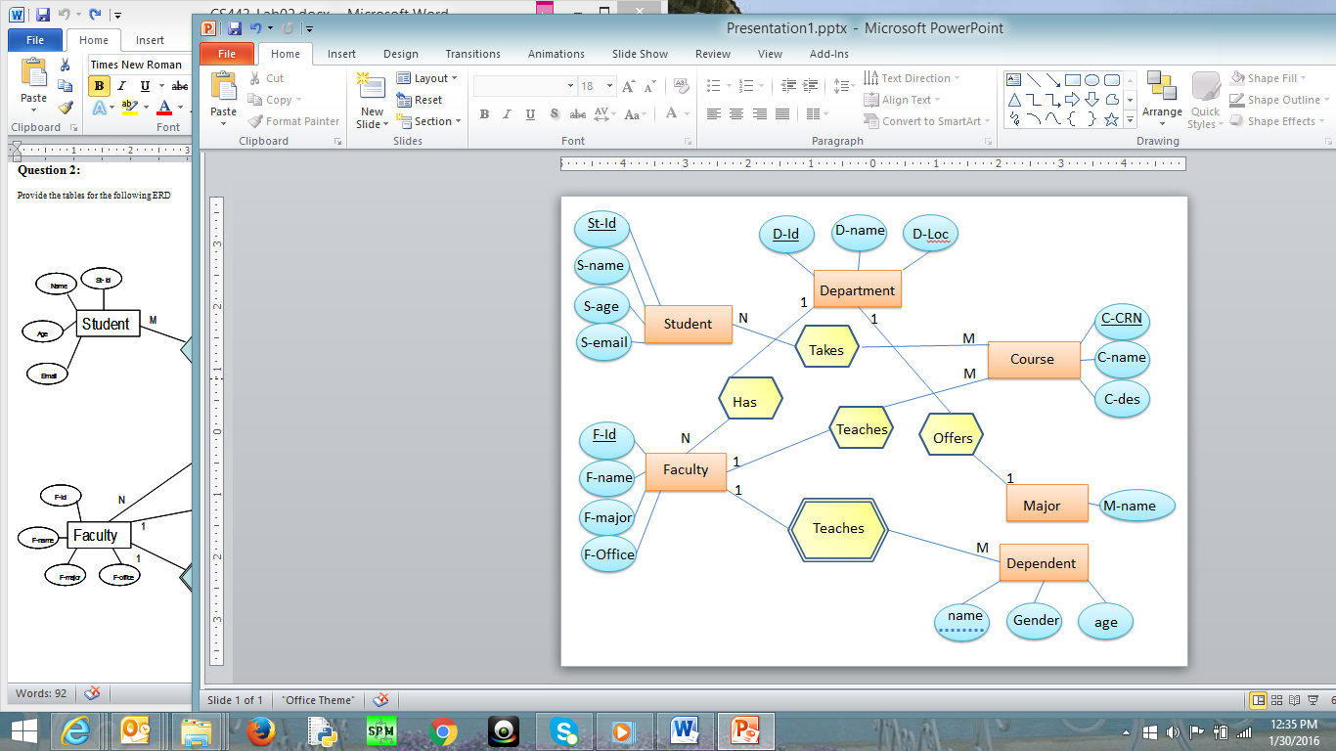

Student(**St-Id**, S-Name, S-Age, S-Email)

Course(**C-CRN**, C-Name,C-Des, F-id )

Takes(**St-Id, C-CRN**) -> Composite primary key, please don’t confuse for two separate underlines.

Department(**D-Id**, D-name, D-loc)

Faculty(**F-Id**, D-id, F-name, F-major, F-Office)

Major (**M-name**, D-id)

Dependent(**name,F-id**, Gender, age) ->Composite primary key, please don’t confuse for two separate underlines.